Homework 8 Question 2

Upon running the following code in CMD:

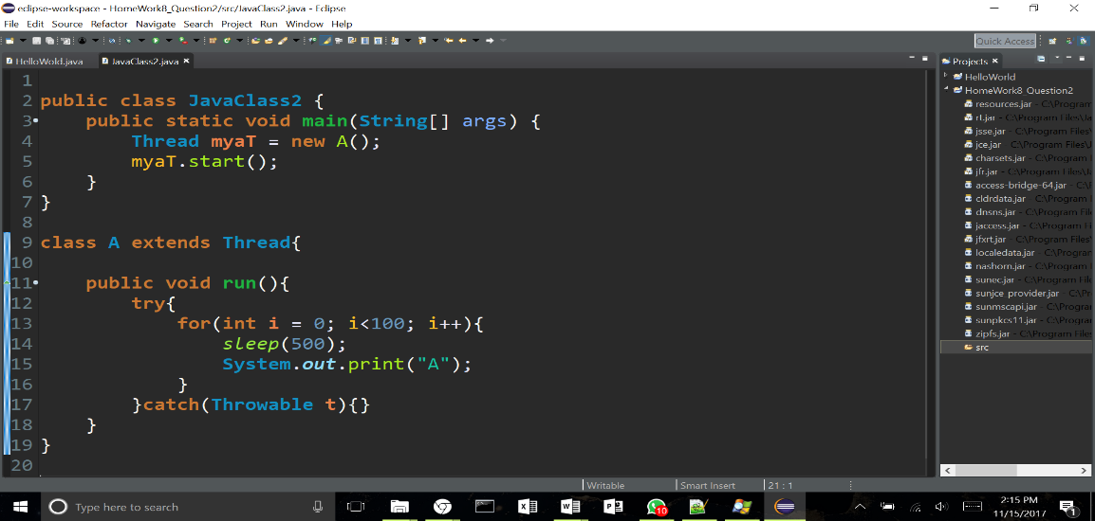

We receive the following output:

>AAAAAAAAAAAAAAAAAAAAAAAAAAAAAAAAAAAAAAAAAAAAAAAAAAAAAAAAAAAAAAAAAAAAAAAAAAAAAAAAAAAAAAAAAAAAAAAAAAAA

However, if one were to use the mark tool in CMD; The program stops printing the output and then only once the esc key is inserted, the program resumes and the program continures where it left off. One would think that the computer would con tiue running this code in the background and the spit out the remainning output after mark is completed. 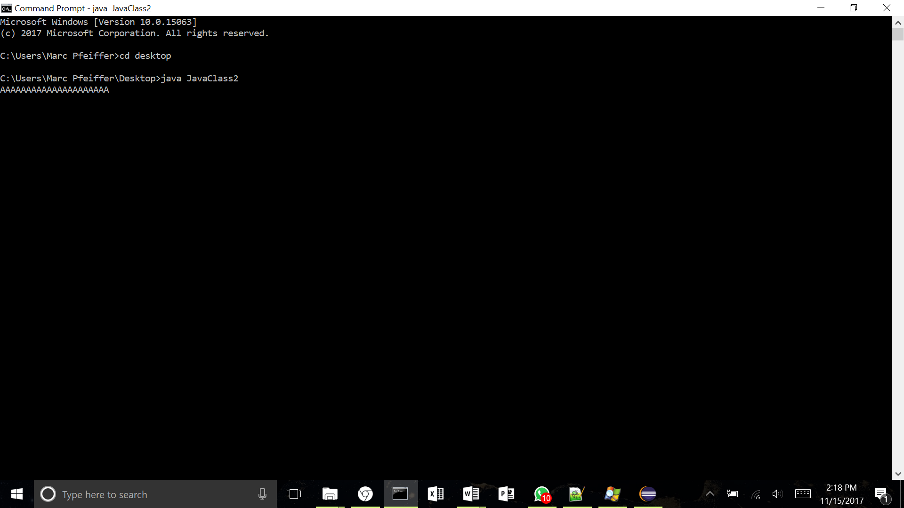

The reason the code stops running is because CMD is waiting for user input and when the user inserts Mark (ctrl - M), one of the threads in that CMD console is running gets put in suspend mode.

One can recreate the same event by opening process explorer and suspending Java.exe itself and then would receive the same result. Only in this case to one would have to press resume to continue the program.

